Instructions for Accessing Fred Hutch’s CITI Courses
Please choose the instructions that apply to you:
- You are a new CITI user
- You are an existing CITI user

New User – CITI – Learner Registration
Step 1:
- Go to the CITI Learner Registration page.
- Search for Fred Hutch in the Select Your Organization Affiliation list and select "Fred Hutchinson Cancer Center". This will ensure the Fred Hutch IRO receives your training records.
- Review the Terms of Service and check “I agree”.
- Check “I affirm that I am an affiliate”.
- Click the “Continue” button. (Do not register as an independent learner.)
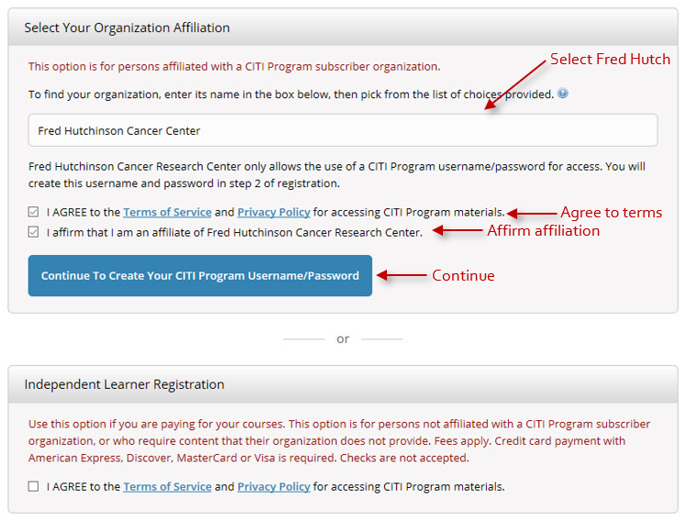
Step 2:
- Enter your full name and email address. Providing a secondary email address is optional.
- Click “Continue to Step 3.”
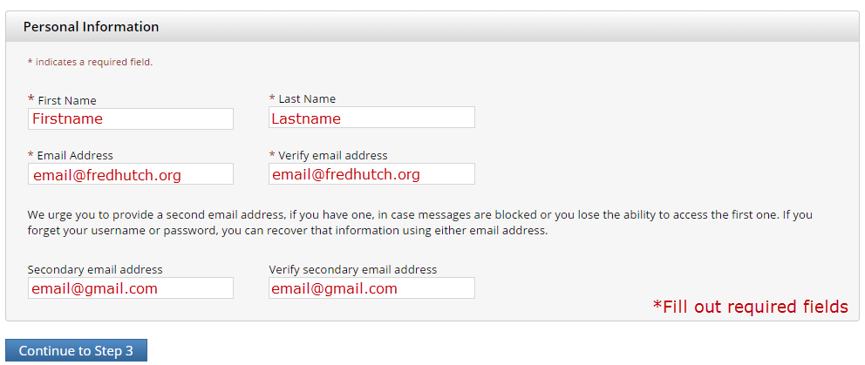
Step 3:
- Create your Username and Password
- Choose a security question and type in a security answer.
- Click “Continue to Step 4”.
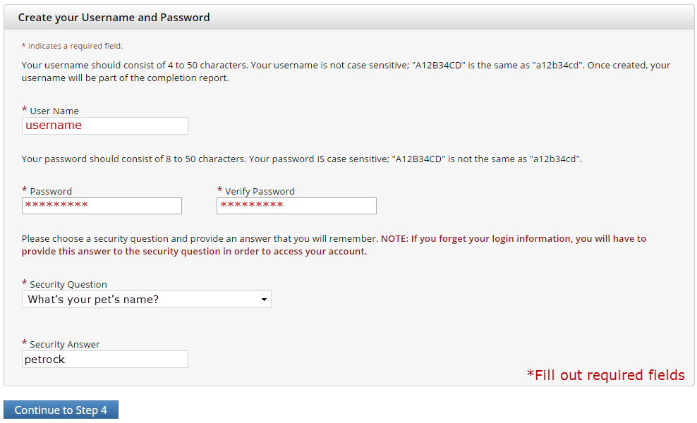
Step 4:
- Select your country of residence.
- Click “Continue to Step 5”.
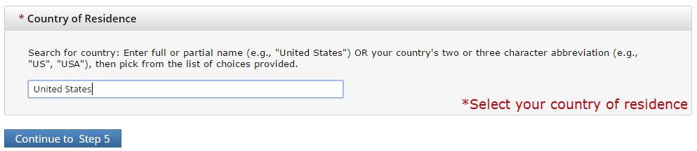
Step 5:
- If you would like to receive other professional Continuing Education Unit (CEU) credit for completed courses, select Yes and choose the type of credit you want to receive. By selecting CEU, you will need to pay for the course credit. Paying for CEU is not required to receive training credit from Fred Hutch.
- If you do not need CEU credit, select No.
- Indicate your preference for CITI to contact you for participation in research surveys.
- Click “Continue to Step 6”.
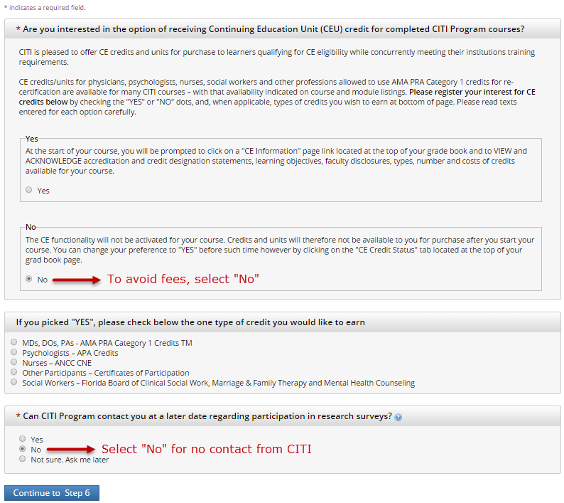
Step 6:
- Provide your Fred Hutch information so that we can identify your training records. Enter your Fred Hutch employee number in both “Employee Number” and “FHCRC ID Number”. If you do not have a Fred Hutch employee number (such as network investigators), please enter 99999.
- Click “Continue to Step 7”.
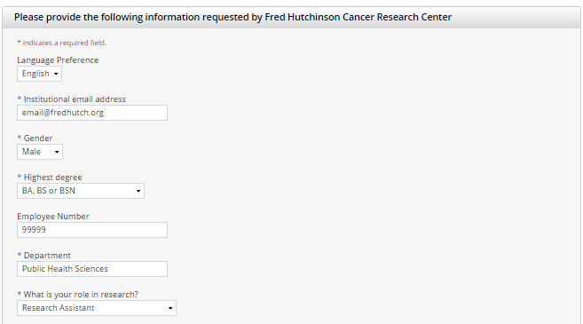
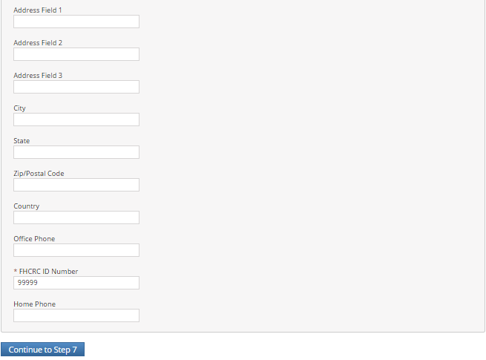
Step 7: Course selection.
- Question 1: select the option(s) that apply to you. If you plan on taking a refresher course, IRO staff may contact you for documentation of your Basic course completion
- Question 2: select the option(s) that apply to you. If you plan on taking a refresher course, IRO staff may contact you for documentation of your Basic course completion
- Answer Questions 3 – 10, if appropriate.
- Click “Submit”.
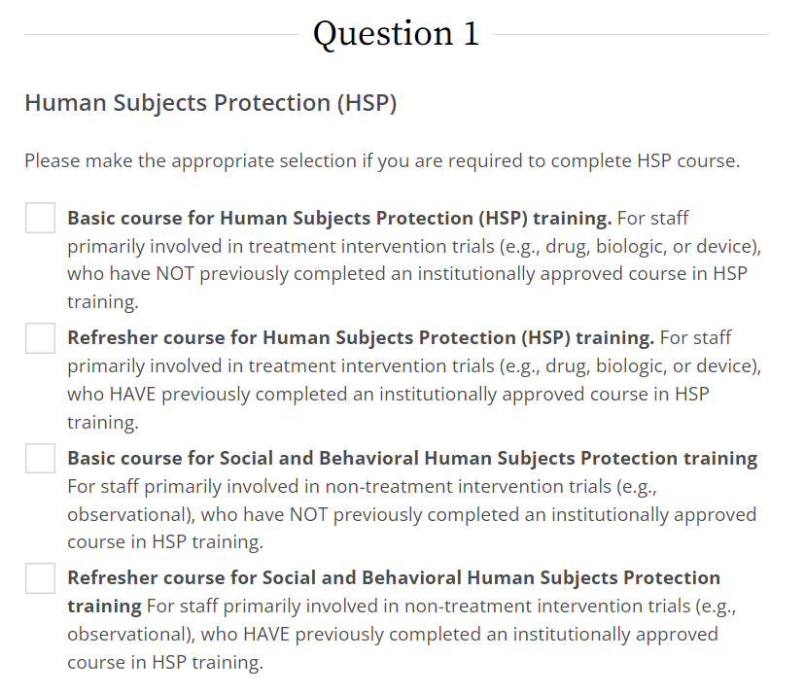
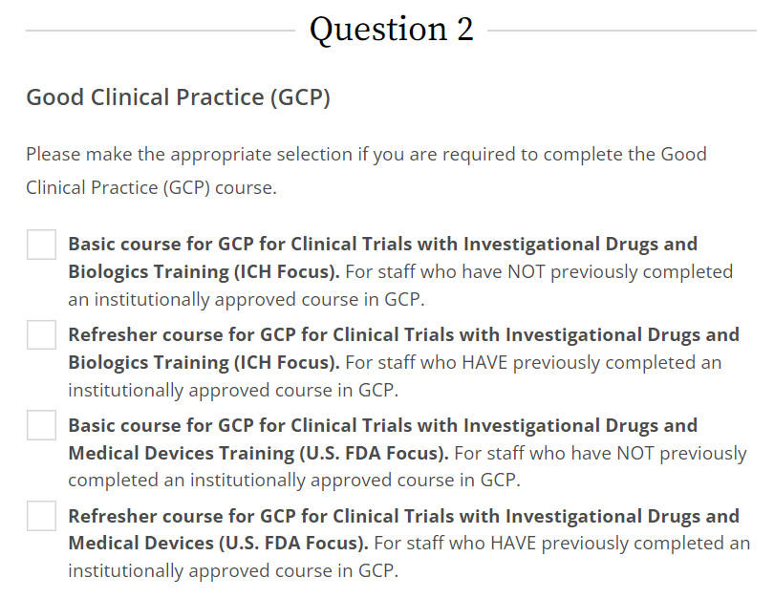
Step 8:
When you have completed the survey, you will have completed your registration. Your courses will be available on the Main Menu.
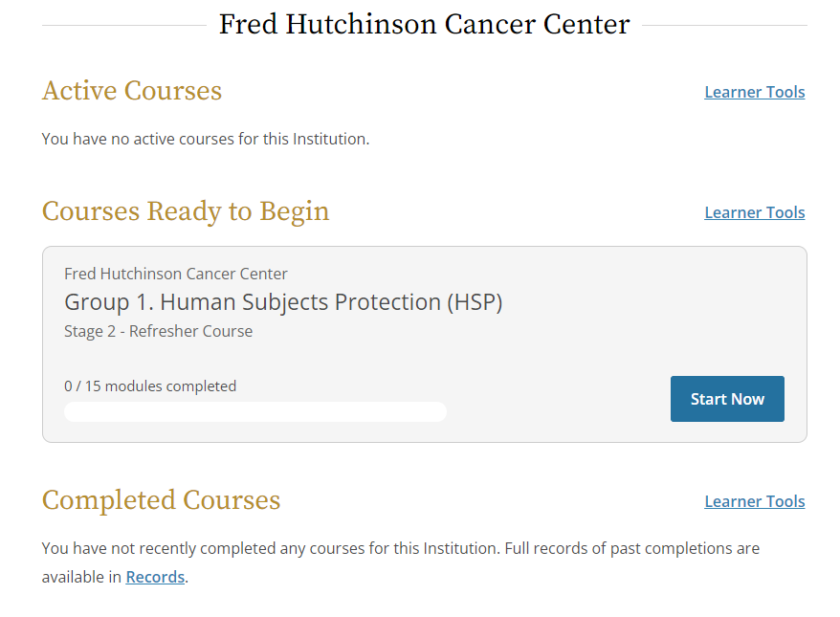

Adding a course for Existing users
Step 1: Log into CITI with your Username and Password.
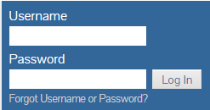
Step 2: Affiliate with Fred Hutchinson Cancer Center to ensure that Fred Hutch IRO receives your training records. If you choose to take a CITI course under another institution’s affiliation, please email a copy of all CITI Completion Reports to iro@fredhutch.org.
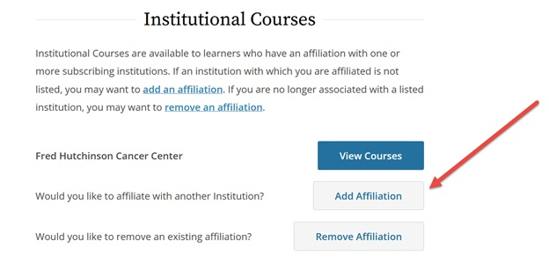
Step 3:
- Click “Add a Course”.
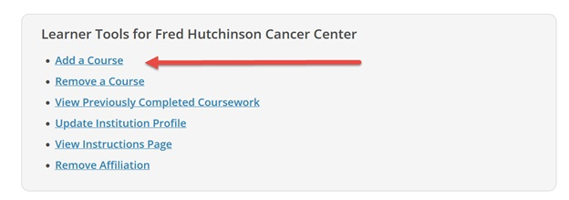
Step 4:
- Question 1: select the option(s) that apply to you. If you plan on taking a refresher course, IRO staff may contact you for documentation of your Basic course completion
- Question 2: select the option(s) that apply to you. If you plan on taking a refresher course, IRO staff may contact you for documentation of your Basic course completion
- Answer Questions 3 – 10, if appropriate.
- Click “Submit”.
Step 5: After you Submit, your courses will be available on the Main Menu.

